**January 20, 2016**

**OVERVIEW OF PMS – SCREENS/FIELDS**

This is a guide which explains the various fields in PMS with regards to Commercial Lines.

PMS – Policy Management System - contains policy information which is used to populate the Accounting, Claims and Reporting systems.

Although PMS has many different screens this guide will focus on the 2 main policy screens.

The first is the PIBC screen which contains Basic Contract information about the Insured/Policy such as Name, Address, Effective/Expiry dates.

The second screen is the PISA screen which contains all of the coverage/statistical information. It can be presented in 3 different ways - property, liability and automobile.

This guide at this time is only going to cover Property and Liability.

Helpful Hints:

Use your <TAB> key or your cursor to move from field to field.

**How to Login:**

From the main login screen type “gateg1”

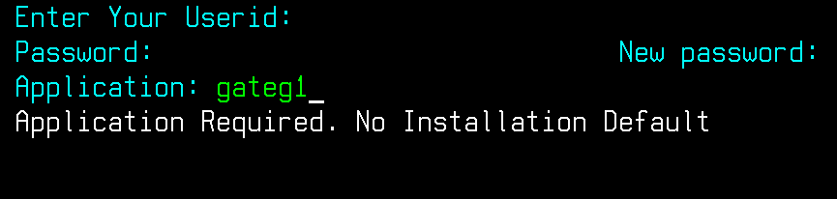

Enter your user id and password and press <Enter>

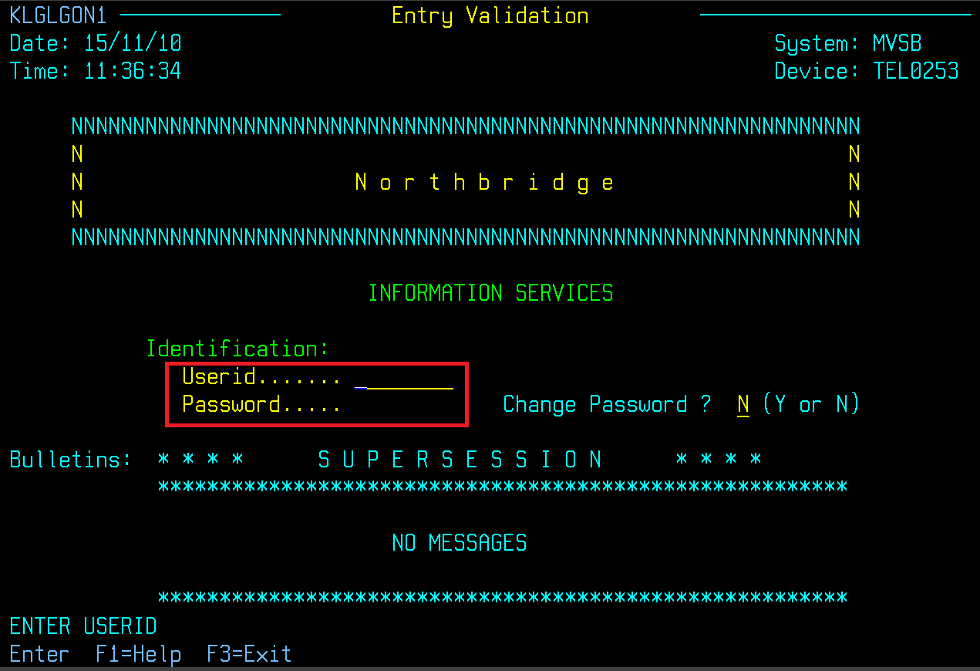

Select “CICSS001 - System test and press <Enter>

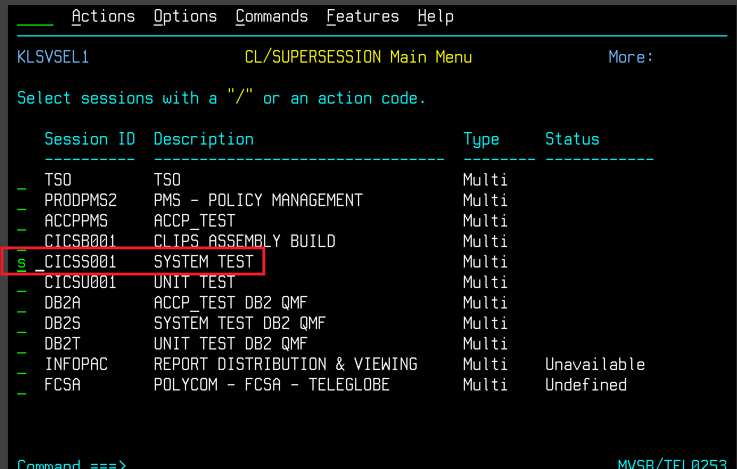

On this screen change the Testfile ID to 8 and press <Enter> twice.

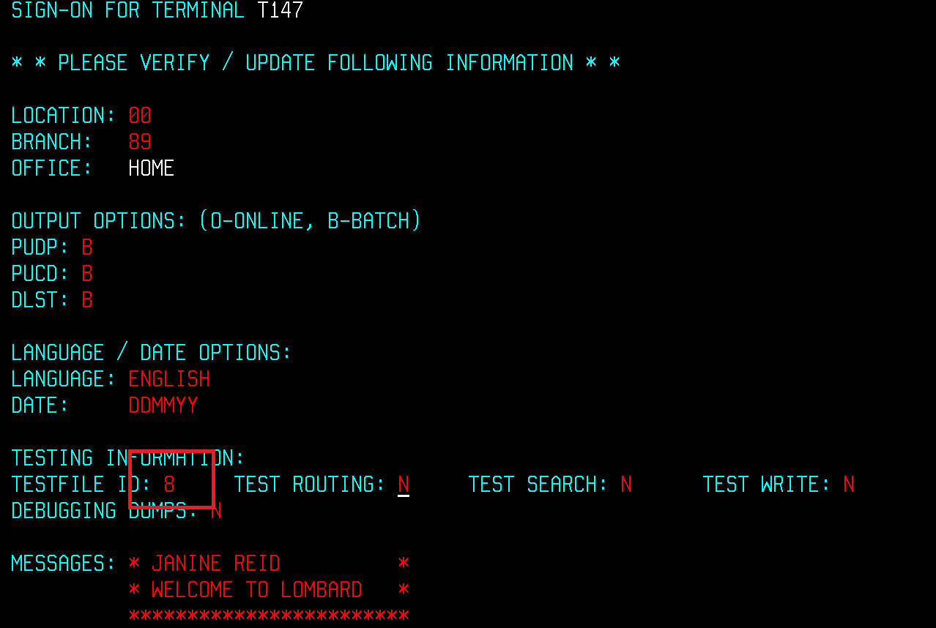Clear your screen.

From a keyboard – Pause/Break

From a laptop:

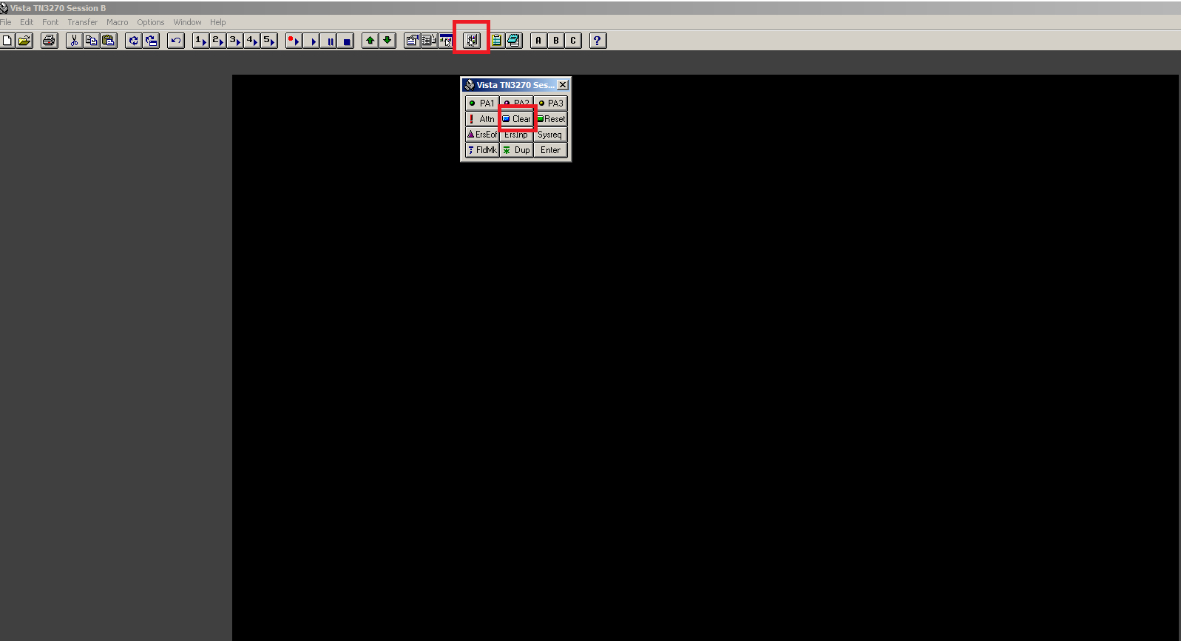

**Viewing/Inquiry a policy in PMS:**

This is commonly referred to as being on the PIF. The policy has passed the nightly cycle and it has been issued.

PIBC <hit the space bar> 7 digit policy number <ENTER> to view the PIBC screen.

Change PIBC to PISA and press <ENTER> to view the statistical screens.

Press <ENTER> to move to the next PISA screen.

To change the SA screen to display the heading for Property or Liability move your cursor (using the tab button) to the empty field beside NX-TB and type in CP for property or LC for Liability and press <Enter>. For automobile the option is AC.

In most cases the heading should automatically appear.

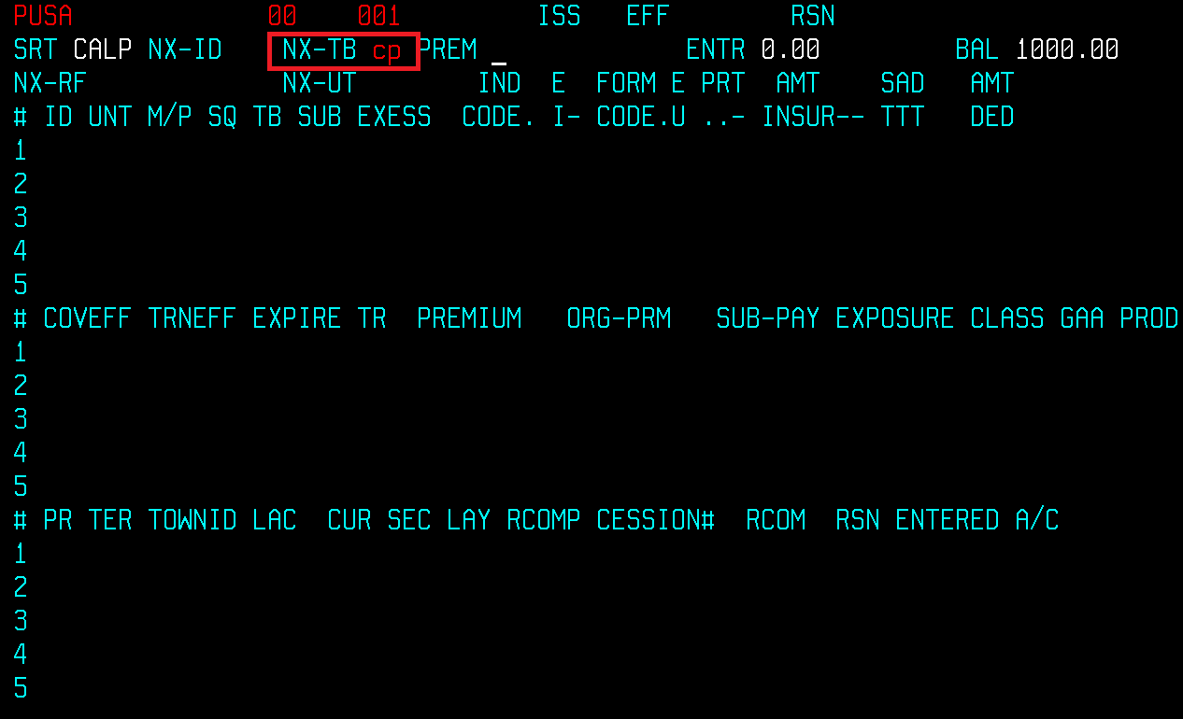

**EPF**

Once a policy has been entered it will sit on the EPF (Entry pending file) for the remainder of the day until it goes through the nightly cycle and it becomes a policy.

**If you need to view a policy on the EPF (From Duck Creek)**

EIBC <hit the space bar> 7 digit policy number <ENTER>

Change EIBC to EISA and press <ENTER> to view the coverage/statistical screens.

Press <ENTER> to move to the next EISA screen.

**If you need to view a policy on the EPF (From Lincq)**

BIBC <hit the space bar> 7 digit policy number <ENTER>

Change BIBC to BISA and press <ENTER> to view the statistical screens.

Press <ENTER> to move to the next BISA screen.

**EINQ:**

There is also the EINQ Policy # which will show all of the screens associated with the

account that are pending going through the nightly cycle.

It shows the symbol, module, region, entry date, first 4 letters of Insured’s name, effective date of change, issue code, reason code, type of screens, Operator id, terminal id, entry date and time.

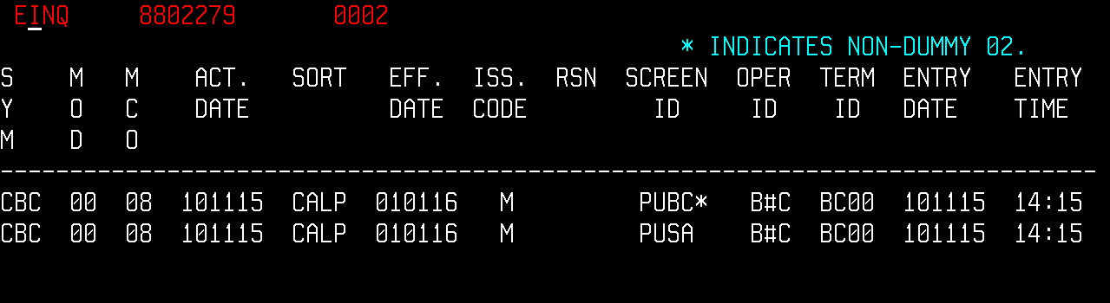

**PUBC Screen– Basic Contract - Field Descriptions**

Blank screen:

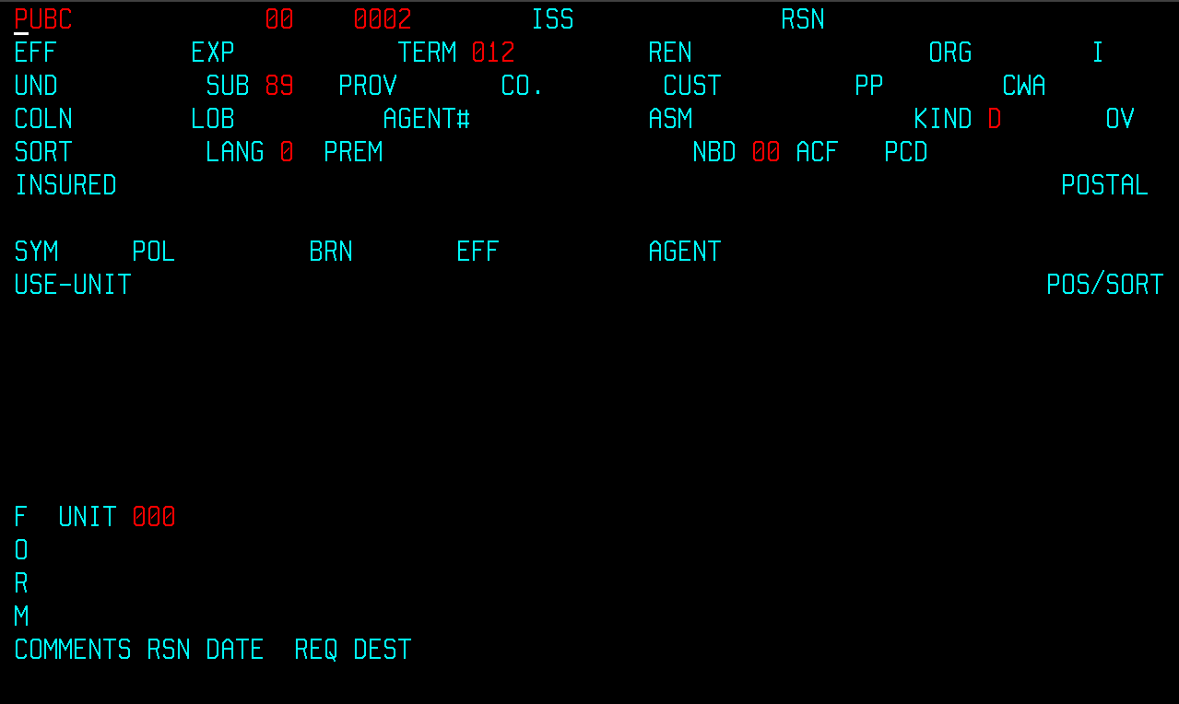

Completed screen:

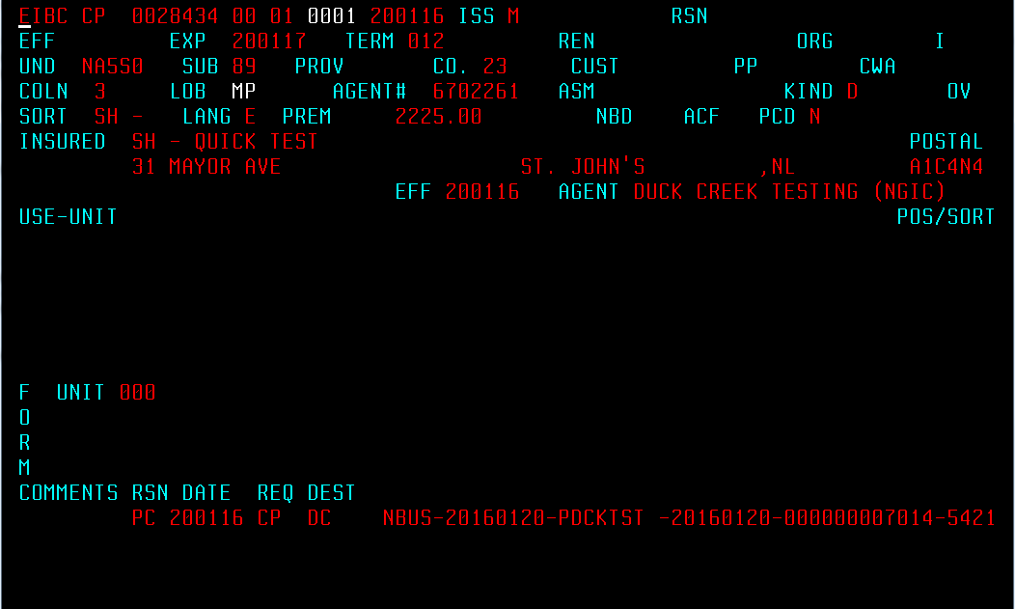

**PIBC** <Space> **<**POLICY NUMBER> <ENTER>

**SYMBOL** CBCBusiness Choice, Manufacturer’s Choice, Farm Choice,

Transportation, Builders’ Choice

CP Duck Creek Policies

**POLICY NUMBER** 7 Digit Numerical

**MODULE** 2 digit Numerical identifying the policy edition. This

Number reflects the number of policy renewals or

Re-writes. Module 00 is new business, 01 is the

First renewal or re-write, etc.

**BRN** Branch **-** 2 digit numerical. It can also be referred to as

**MCO.**

Central Region = 05 (ON)

Quebec Region = 07 (QC)

Atlantic = 08 (NL, NS, PE, NB)

Western = 19 (MB, AB, BC, YT, NT, NU)

Specialty Lines = 81 (Farm, Cross Border, Specialty Lines)

**ISS** Issue Code

M Manual transaction

P Pro Rata Cancellation

S Short Rate Cancellation

6 Short Rate Reinstatement

9 Pro Rata Reinstatement

**EFF** ddmmyyEffective date of change if doing an endorsement, cancellation, reinstatement.

**RSN** Reason Code (For endorsements, cancellations, reinstatements) 2 positions

**Examples:**

AC - Add Coverage

DC – Delete Coverage

CC – Change Coverage

XR – Correct Delcaration

PIO – Flat Cancel

PRW – Cancel and Replace

SIF – Short Rate Insured’s Request

OY - Reinstatement

**EFF** ddmmyy Effective Date of the policy

**EXP** ddmmyyExpiry Date of the policy

**TERM** 3 position numerical – number of months the policy is in

Force. Example: 012 for a 12 month policy

006 for a 6 month policy

**REN** Renewal – Displays the previousPolicy #

**ORG** MM/YYOriginaldate of inception

**UND** Underwriting Code

NA5N0 – Business Choice (2nd Position is A)

NB5N0 – Builders’ Choice (2nd Position is B)

NC5N0 – Cross Border (2nd Position is C)

NF5N0 – Farm Choice (2nd Position is F)

NA5S0 – Small Business (4th position is S)

NA5N0 – Non Technical Risk (4th position is N)

NA5T0 – Technical Risk (4th position is T)

NA5N9 – If the last digit of the UND Code is 9 it means the policy has been cancelled.

NA5N3 – If the last digit of the UND Code is 3 it means the policy has been renewed.

NA5N7 – If the last digit of the UND Code is 7 it means the policy has been lapsed.

**SUB** Sub Branch

87 – Atlantic (NL, PE, NS, NB)

89 – Central (ON)

27 – Quebec (QC)

58 – Western (BC, AB, SK, MB, NT, NU, YT)

90 - Specialty Lines

**PROV** Province

BC, AB, SK, MB, YT, NT, NU, ON, QC, NB, NS, PE, NL

**CO** Policy Company Number

23 NGIC Agency Bill

73 NGIC Direct Bill

55 Tokio Agency Bill

75 Tokio Direct Bill

36 Federated Agency Bill

86 Federated Direct Bill

31 Zenith Agency Bill

81 Zenith Direct Bill

**CUST** Customer Number - 7 digit numerical also referred to

As the Direct Bill (Accounting) number

**PP** Payment Plan (if on Direct Bill)

1 Payment (Annual)

2 Payments (Semi Annual)

3 Payments

4 Payments

C Monthly

**CWA** Cash with Application

This is a down payment/deposit for a Direct Bill policy and used by the Direct Bill System. Entry is in dollars and cents.

**COLN** 3 Company Line (For Commercial Lines)

**LOB** Line of Business (For Commercial Lines)

BC - Business Choice

MP - Duck Creek

**AGENT#** Agency Number - 7 digit numerical

**ASM** Assumed Business - Defaults to D

**KIND**  KIND

This indicates if the policy is Direct Assumed or Ceded.

Defaults to D

D Direct

A Assumed

C Ceded

**SORT** First 4 letters/numbers of the Insured’s Name

**LANG** Language of policy documents

E = English

F = French

**PREM** Premium

**NBD** New Business Discount – Not used by Commercial Lines (Used by Personal Lines)

**ACF** Additional Claims Free Discount – Not used by Commercial Lines (Used by Personal Lines)

**PCD** Personal Choice Discount - Not used by Commercial Lines (Used by Personal Lines)

**INSURED** This is for the Insured’s Name and Address. There are 4 fields. Each field is 30 positions.

Name Name

Address City, Province

Example:

1234567 Ontario Limited Joe’s Bakery

123 Church Street Toronto, Ontario

**POSTAL**  Postal Code of Insured

**SYM** CBCSymbol **-** Business Choice, Manufacturer’s Choice,

Farm Choice, Transportation

CP Duck Creek

**POL** Policy Number - 7 digits

**BRN** Branch - 2 digit numerical

Central Region = 05 (ON)

Quebec Region = 07 (QC)

Atlantic = 08 (NL, NS, PE, NB)

Western = 19 (MB, AB, BC, YT, NT, NU)

Specialty Lines = 81 (Farm)

**EFF** ddmmyy Effective Date of the Policy

**AGENT** Agency Name

Example: Marsh Canada Ltd.

**USE-UNIT** This is an area to enter Miscellaneous comments.

Example:

MI 001 1 Keyed by Heather R.

MI 001 2 Endorsement #2 is adding vehicle #7.

**POS/SORT** Not applicable for Commercial Lines

**COMMENTS** Comments will appear in this area

Examples include a PC Comment – Permanent Comment.

**PC Comment from Lincq**:



This comment is system generated and includes the effective date of the policy, the policy

symbol, the quote/iteration from Lincq, Qlog# and the i.d. of the person who accepted it.

**PC Comment from Duck Creek:**



This comment is system generated and includes the transaction type, transaction effective

date of the policy, the i.d. of the person who accepted it, date accepted, Duck Creek 12

bytes key and policy IBC Code

**BI Banking Information Comment: (Same for both Lincq and Duck Creek)**



E = the effective date of withdrawl, B = Bank #, T= Transit #, A = Bank Account #

**CC Credit Card Comment from Lincq:**



This comment is system generated and includes the card number, date and card holder’s

name.

**CC Credit Card Comment from Duck Creek:**



This comment is system generated and includes dummy card number, date and card

holder’s name.

**CM Claims Made Comment:**



If any coverage is claims made this comment should appear with the effective date of the policy.

**RI Comment:**



There is also **a RI Comment** – changing from agency bill to direct bill (used by Lincq policies)

**PUSA screen – Type CP – Property**

**Blank Screen:**

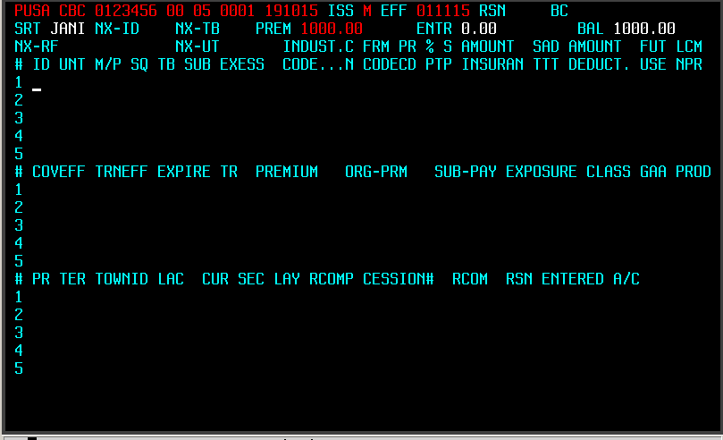

Completed Screen:

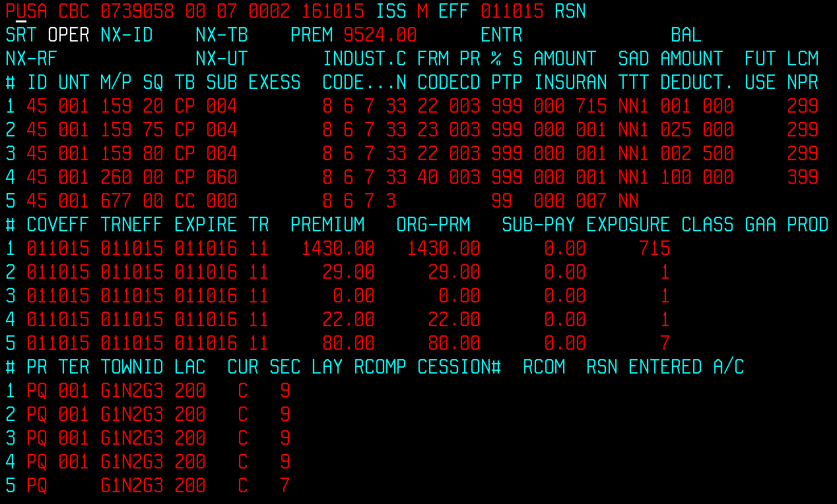

**ID** Identification – This is the segment Identification

Number. It is always 45

**UNIT** Unit # - Location number

(From Lincq any Garage locations begin with a 5.

Example: Garage Location one would be 501.

**M/P** Major Peril – Indicates the type of policy coverage. Each coverage has a major peril. (See spreadsheet attached)

**SQ** Sequence – Each coverage has a sequence. (See spreadsheet attached)

**TB** Type Bureau – Indicates the type of statistical

reporting plan

Property = CP

Liability = LC

Automobile = AC

Inland Marine = CP

Boiler = CC

**SUB** Sub Line – Used for statistical reporting plan. Each coverage has a sub line. (See spreadsheet attached)

**EXCESS** If the policy has reinsurance the type and excess

amount would appear here.

**INDUST   
CODE** Industry (IBC) Code

See IBC Manuals for appropriate codes

GTAM CPINCD

**C**

**N** Construction

1 – Fire Resistive

2 – Non Combustible with Masonry Walls

3 – Non Combustible with Non Masonry Walls

4 – Masonry

5 – Masonry Veneer

6 – Frame

9 – Not Applicable

**FRM  
CODE** Form Code – up to 4 positions. Each coverage has a

form code. See spreadsheet attached)

**PR**

**CD** Protection Code

1 = Protected

2 = Protected

3 = Protected

4 = Protected

5 = Semi-Protected

6 = Semi-Protected

7 = Semi-Protected

8 = Unprotected

9 = Unprotected

10 = Unprotected

**%**

**PT** Percentage of Participation.

If the policy is subscribed this would show the

Northbridge portion. Example if we are on for 60% it

would show 60.

If not subscribed it would show 99.

**S**

**P** Sprinkler ID

1 = Sprinklered

9 = Non Sprinklered (Not Applicable)

**AMOUNT**

**INSURAN** Amount of Insurance

Indicates the limit of coverage.

Coverage is in thousands of dollars.

Example: 0001 = $1,000 Amount of Insurance

0100 $100,000 Amount of Insurance

1000 $1,000,000 Amount of Insurance

Example if a building is valued at $100,000 you would

See 0100 in the field.

**S  
T** Surplus Treaty ID (used if policy has reinsurance)

**A**

**T** Audit Transaction ID

N = No Audit

Y = Audit applies

**D**

**T** Deductible Type

1 – Actual $ amount

2 - % of the Amount of Insurance

3 - % of the Loss Incurred

4 – Disappearing Deductible

5 – Multiple Deductible

6 – Time Period Deductible

9 – No Deductible

**AMOUNT  
DEDUCT**. Amount of Deductible.

Example:

$ 500 deductible = 00500

$ 1,000 deductible = 01000

$ 10,000 deductible = 10000

**FUT  
USE** Future Use

**L**

**N** Line Code

1 – Named Perils

2 – Broad Form

3 – Earthquake

4 – Glass

5 – Crime/Fidelity

**CM** Crime Protection  
**PR**

10 – No protection

20 – One or more security guards

30 – Burglar Alarm (local)

40 – Burglar Alarm (central station)

50 – Other than above/unknown

99 – Not Applicable

**COVEFF** Coverage Effective Date

**TRNEFF** Transaction Effective Date

**EXPIRE** Coverage Expiry Date

**TR** Transaction Code

10 New Business

11 Renewal Business or Renewal Certificate

12 Additional Premiums

15 Reinstatements

20 Flat Cancellations on New Business

21 Flat Cancellations on Renewals

22 Return Premiums

23 Cancellations Other Than Flat on New Business

25 Cancellations Other Than Flat on Renewals

**PREMIUM** Transaction Premium

**ORG-PRM** Original (Annual Premium)

**SUB-PAY** Subsequent Payment Amount – used for deferred

payment policies.

**EXPOSURE** Displays the limit of the coverage for New Business or

Renewal – in **thousands**. If it’s an endorsement the Exposure is the net change of limit.

**New Business – If limit of cov is 100,000 the Exposure would be 100**

**Endorsement – If limit of cov is changed from 100,000 to 175,000 the Exposure would be 75**

**CLASS** This was used for IBC Statistical Class for personal

property coverage – No longer used (was MOAC, BOX)

**GAA** This was used for Automobile Discount - No longer

used (was MOAC, BOX)

**PROD** Production Line - Identifies the policy type by

line of business.

**PR** Province

NL Newfoundland (60)

AB Alberta (61)

BC British Columbia (62)

MB Manitoba (63)

NB New Brunswick (64)

NS Nova Scotia (65)

PE Prince Edward Island (66)

ON Ontario (67)

PQ Quebec (68)

SK Saskatchewan (69)

YT Yukon (70)

NU Nunavut (71)

NT Northwest Territory (80)

* **FOR UNIT 999, USE CLIENT PROV**

**TER** Territory – Indicate the number of risk location for a specific exposure.

**- FOR TYPE-BUREAU 'CP', USE ‘001’**

**TOWNID** If coming from Lincq - The Town ID would be the Postal Code of the location if Property coverage.

If coming from Duck Creek – The first 3 positions will indicate the location number and the next 3 positions will indicate the building number.

Example 001001 is Location 1, Building 1

**LAC** Agent’s Commission – 3 position numerical

Example: 20% = 200, 7.5% = 075, 17.5% = 175

(See spreadsheet attached)

**CUR** Currency

C = Canadian

U = U.S. dollars

**SEC** Section Code - Each coverage has a section code. (See spreadsheet attached)

**LAY** Layers - Used when a policy has Reinsurance

**RCOMP** Reinsurance Company Number

Examples: 3XEU or 3582

**CESSION#** Reinsurance Policy Number

**RCOM** Reinsurer’s Commission

**RSN**  Reason Code if endorsed, cancelled, reinstated, etc.

**Examples:**

AC - Add Coverage

DC – Delete Coverage

CC – Change Coverage

XR – Correct Delcaration

PIO – Flat Cancel

PRW – Cancel and Replace

SIF – Short Rate Insured’s Request

OY - Reinstatement

**ENTERED**  Date the policy went through the nightly cycle

**A/C** MM/YY Accounting Month – this is the month/year the policy

Has been processed in the accounting system.

For New Business/Renewals it will be the same as the

Effective date of the policy.

**PUSA screen – Type CC – Property**

**Blank Screen:**

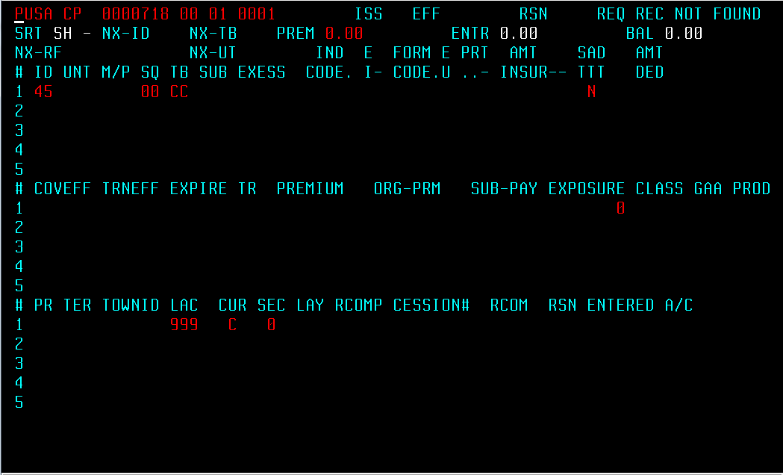

Completed Screen:

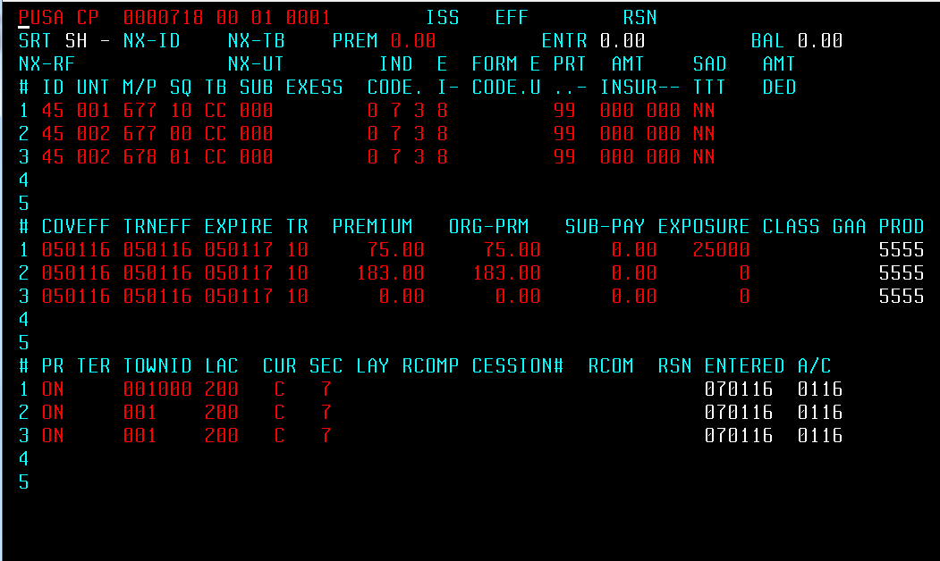

**ID** Identification – This is the segement Identification

Number. It is always 45

**UNIT** Unit # - Location number

(From Lincq any Garage locations will beging with a 5.

Example: Garage Location one would be 501.

**M/P** Major Peril – Indicates the type of policy coverage. Each coverage has a major peril. (See spreadsheet attached)

**SQ** Sequence – Each coverage has a sequence. (See spreadsheet attached)

**TB** Type Bureau – Indicates the type of statistical

reporting plan

Property = CP

Liability = LC

Automobile = AC

Inland Marine = CP

Boiler = CC

**SUB** Sub Line – Used for statistical reporting plan. Each coverage has a sub line. (See spreadsheet attached)

**EXCESS** If the policy has reinsurance the type and excess

amount would appear here.

**INDUST   
CODE** Industry (IBC) Code

See IBC Manuals for appropriate codes

GTAM CPINCD

**C**

**N** Construction - Blank

**FRM  
 CODE** Form Code – Blank

**PR**

**CD** Protection Code - Blank

**%**

**PT** Percentage of Participation

If the policy is subscribed this would show the

Northbridge portion. Example if we are on for 60% it

would show 60.

If not subscribed it would show 99.

**S**

**P** Sprinkler ID - Blank

**AMOUNT**

**INSURAN** Amount of Insurance

Indicates the limit of coverage.

Coverage is in thousands of dollars.

Example: 0001 = $1,000 Amount of Insurance

0100 $100,000 Amount of Insurance

1000 $1,000,000 Amount of Insurance

Example if a building is valued at $100,000 you would

See 0100 in the field.

**S  
T** Surplus Treaty ID (used if policy has reinsurance)

**A**

**T** Audit Transaction ID

N = No Audit

Y = Audit applies

**D**

**T** Deductible Type - Blank

**AMOUNT  
DEDUCT**. Amount of Deductible - Blank

**FUT  
USE** Future Use

**L**

**N** Line Code - Blank

**CM** Crime Protection - Blank  
**PR**

**COVEFF** Coverage Effective Date

**TRNEFF** Transaction Effective Date

**EXPIRE** Coverage Expiry Date

**TR** Transaction Code

10 New Business

11 Renewal Business or Renewal Certificate

12 Additional Premiums

15 Reinstatements

20 Flat Cancellations on New Business

21 Flat Cancellations on Renewals

22 Return Premiums

23 Cancellations Other Than Flat on New Business

25 Cancellations Other Than Flat on Renewals

**PREMIUM** Transaction Premium

**ORG-PRM** Original (Annual Premium)

**SUB-PAY** Subsequent Payment Amount – used for deferred

payment policies.

**EXPOSURE** Displays the limit of the coverage for New Business or

Renewal – in **thousands**. If it’s an endorsement the Exposure is the net change of limit.

**New Business – If limit of cov is 100,000 the Exposure would be 100**

**Endorsement – If limit of cov is changed from 100,000 to 175,000 the Exposure would be 75**

**CLASS** This was used for IBC Statistical Class for personal

property coverage – No longer used (was MOAC, BOX)

**GAA** This was used for Automobile Discount - No longer

used (was MOAC, BOX)

**PROD** Production Line - Identifies the policy type by

line of business.

**PR** Province

NL Newfoundland (60)

AB Alberta (61)

BC British Columbia (62)

MB Manitoba (63)

NB New Brunswick (64)

NS Nova Scotia (65)

PE Prince Edward Island (66)

ON Ontario (67)

PQ Quebec (68)

SK Saskatchewan (69)

YT Yukon (70)

NU Nunavut (71)

NT Northwest Territory (80)

* **FOR UNIT 999, USE CLIENT PROV**

**TER** Territory – Indicate the number of risk location for a specific exposure - Blank

**TOWNID** If coming from Lincq - The Town ID would be the Postal Code of the location if Property coverage.

If coming from Duck Creek – The first 3 positions will indicate the location number and the next 3 positions will indicate the building number.

Example 001001 is Location 1, Building 1

**LAC** Agent’s Commission – 3 position numerical

Example: 20% = 200, 7.5% = 075, 17.5% = 175

(See spreadsheet attached)

**CUR** Currency

C = Canadian

U = U.S. dollars

**SEC** Section Code - Each coverage has a section code. (See spreadsheet attached)

**LAY** Layers - Used when a policy has Reinsurance

**RCOMP** Reinsurance Company Number

Examples: 3XEU or 3582

**CESSION#** Reinsurance Policy Number

**RCOM** Reinsurer’s Commission

**RSN**  Reason Code if endorsed, cancelled, reinstated, etc.

**Examples:**

AC - Add Coverage

DC – Delete Coverage

CC – Change Coverage

XR – Correct Delcaration

PIO – Flat Cancel

PRW – Cancel and Replace

SIF – Short Rate Insured’s Request

OY - Reinstatement

**ENTERED**  Date the policy went through the nightly cycle

**A/C** MM/YY Accounting Month – this is the month/year the policy

Has been processed in the accounting system.

For New Business/Renewals it will be the same as the

Effective date of the policy.

**TB – Type Bureau – LC – Typically Liability Coverages”**

Blank

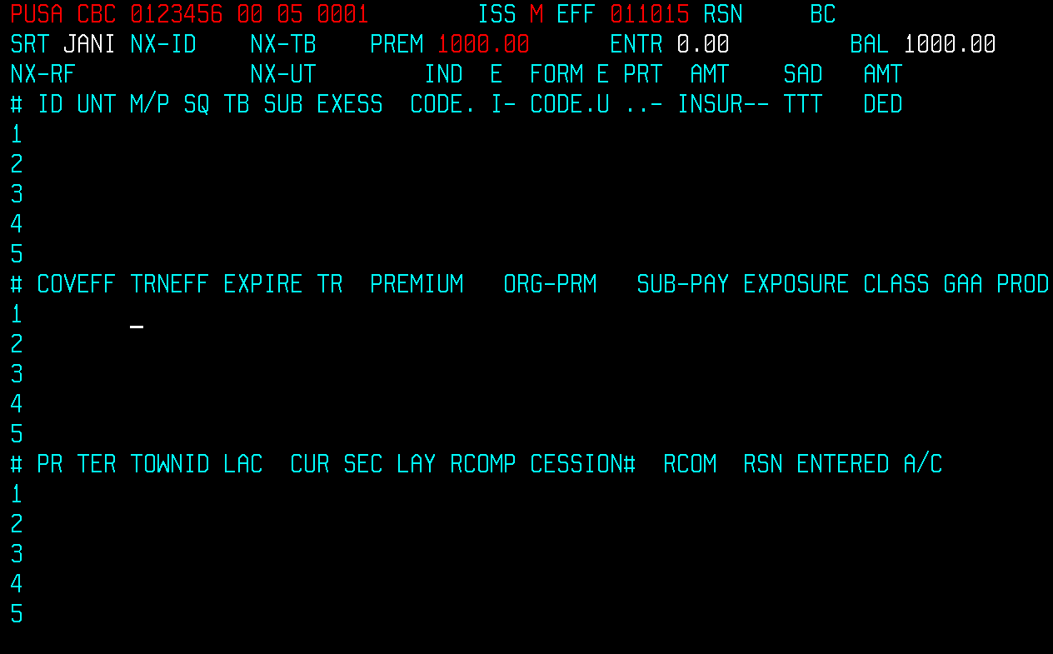

Completed

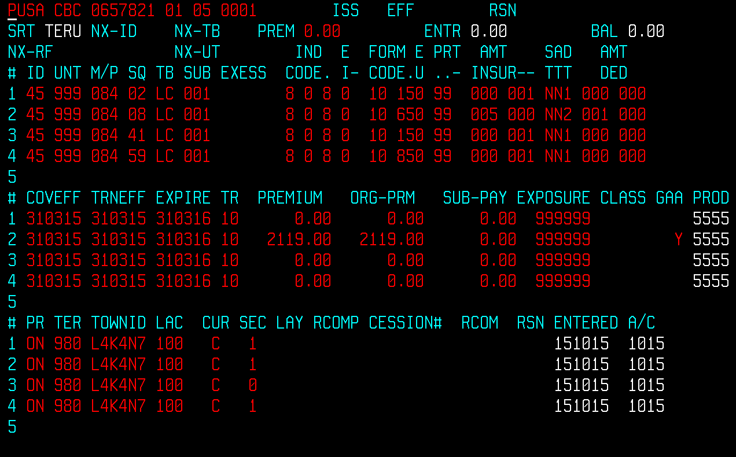

**ID** Identification – This is the segement Identification

Number. It is always 45

**UNIT** Unit # - Coverages such as Liability, Crime,

Umbrella and Inland Marine will have a Unit # of 999.

**M/P** Major Peril – Indicates the type of policy coverage. Each coverage has a major peril. (See spreadsheet attached)

**SQ** Sequence – Each coverage has a sequence. (See spreadsheet attached)

**TB** Type Bureau – Indicates the type of statistical

reporting plan

Property = CP

Liability = LC

Automobile = AC

Inland Marine = CP

Boiler = CC

**SUB** Sub Line – Used for statistical reporting plan. Each coverage has a sub line. (See spreadsheet attached)

**EXCESS** If the policy has Reinsurance the type and excess amount would appear here.

**IND  
CODE** Industry (IBC) Code

See IBC Manuals for appropriate codes

Example:

**E** Filler

**I**

**FORM  
CODE** Form Code – up to 4 positions.

Each coverage has a form code. (See spreadsheet attached)

**E**

**U** Exposure Base Unit

**PRT** Percent Participation followed by filler – allways 99 for

Liability

**AMT**

**INSUR** Amount of Insurance – indicates the limit of coverage.

Coverage is in thousands of dollars.

Example: 0001 = $1,000 Amount of Insurance

0100 $100,000 Amount of Insurance

1000 $1,000,000 Amount of Insurance

**S  
T** Surplus Treaty ID (used if policy has reinsurance)

**A**

**T** Audit Transaction ID

N = No Audit

Y = Audit applies

**D**

**T** Deductible Type

1 – No Deductible

2 – Per Occurrence Basis

3 – Per Claimant Basis

4 – Other

**AMT  
DED** Amount Deductible.

Example:

$ 500 deductible = 00500

$ 1000 deductible = 01000

$ 10000 deductible = 10000

**COVEFF** Coverage Effective Date

**TRNEFF** Transaction Effective Date

**EXPIRE** Coverage Expiry Date

**TR** Transaction Code

10 New Business

11 Renewal Business or Renewal Certificate

12 Additional Premiums

15 Reinstatements

20 Flat Cancellations on New Business

21 Flat Cancellations on Renewals

22 Return Premiums

23 Cancellations Other Than Flat on New Business

25 Cancellations Other Than Flat on Renewals

**PREMIUM** Transaction Premium

**ORG-PRM** Original (Annual Premium)

**SUB-PAY** Subsequent Payment Amount – no longer used

**EXPOSURE** Displays the limit of the coverage for New Business or

Renewal – in **thousands**. If an endorsement the Exposure is the net change of limit.

**New Business – If limit of cov is 100,000 the Exposure would be 100**

**Endorsement – If limit of cov is changed from 100,000 to 175,000 the Exposure would be 75**

**If Exposure is not applicable, use “999999”**

**It’s always 999 999” except for 084 01**

**CLASS** This was used for IBC Statistical Class for personal

property coverage – No longer used (was MOAC, BOX)

**GAA** This was used for Automobile Discount - No longer

used (was MOAC, BOX)

**PROD** Production Line - Identifies the policy type by

line of business.

**PR** Province

NL Newfoundland (60)

AB Alberta (61)

BC British Columbia (62)

MB Manitoba (63)

NB New Brunswick (64)

NS Nova Scotia (65)

PE Prince Edward Island (66)

ON Ontario (67)

PQ Quebec (68)

SK Saskatchewan (69)

YT Yukon (70)

NU Nunavut (71)

NT Northwest Territory (80)

**TER Unknown Territory**

**TOWNID** Postal Code

**LAC** Agent’s Commission – 3 position numerical

Example: 20% = 200, 7.5% = 075, 17.5% = 175

(See spreadsheet attached)

**CUR** Currency

C = Canadian

U = U.S. dollars

**SEC** Section Code - Each coverage has a major peril. (See separate spreadsheet

**LAY** Layers - Used if Layers of Reinsurance

**RCOMP** Reinsurance Company Number

Examples: 3XEU or 3582

**CESSION#** Reinsurance Policy Number

**RCOM** Reinsurer’s Commission

**RSN**  Reason Code if endorsed, cancelled, reinstated, etc.

**Examples:**

AC - Add Coverage

DC – Delete Coverage

CC – Change Coverage

XR – Correct Delcaration

PIO – Flat Cancel

PRW – Cancel and Replace

SIF – Short Rate Insured’s Request

OY - Reinstatement

**ENTERED**  Date the policy went through the nightly cycle

**A/C** MM/YY Accounting Month – this is the month/year the policy

Has been processed in the accounting system.

For New Business/Renewals it will be the same as the

Effective date of the policy.